Name: Donark Patel
LAB 1 Answer sheet (download from campus cruiser and edit
1) Nothing required for this question
2) You should have a text file stored on your usb drive
3) You should have Template.java stored on your usb drive
4) Lab1a: Use copy/paste to document output (paste below)
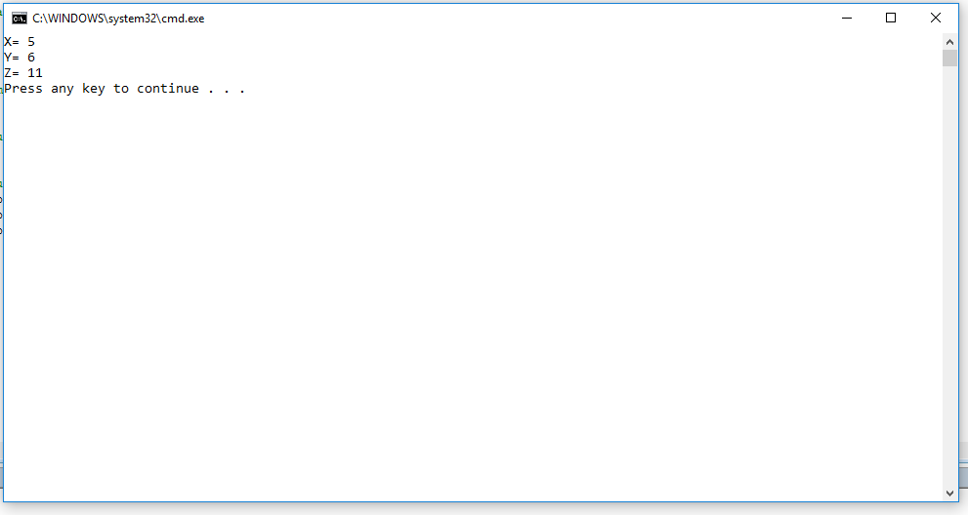
5) Lab1b: Use snipping tool to show output, make sure title bar is showing. You do not need to show entire screen, just the portion with output. If done correctly the background will be white.(paste below)
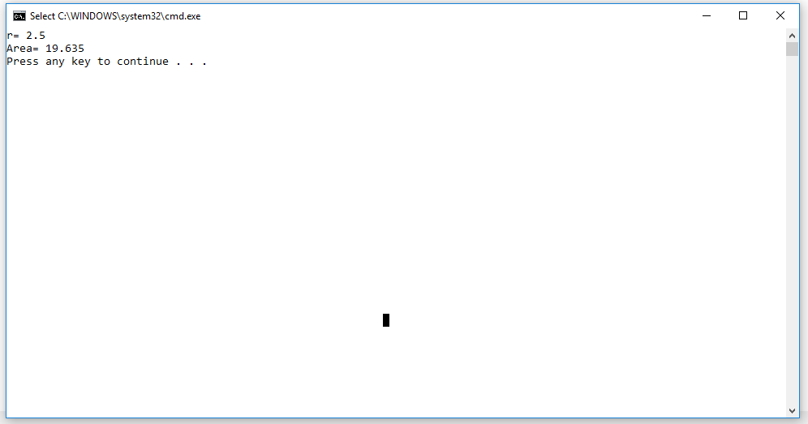

6) Lab1c: Data types Enter maximum number of decimals
int (i1) 15
float (f1) 2.12356516898F
double (d1) 5.1236

Paste output showing maximum number of decimals below
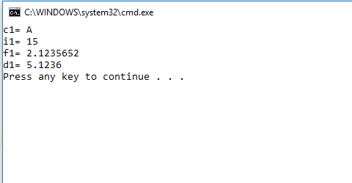
7) Variable names – make descriptive names

aaa isoBase bbb isoHight area1
ccc rightBase ddd rightHight area2
eee blueHight fff blueBase area3
ggg redHight hhh redBase area4

8) Lab1d Variable names, search and replace
Print out code listing (after variable names are replaced )
Paste output below using snipping tools

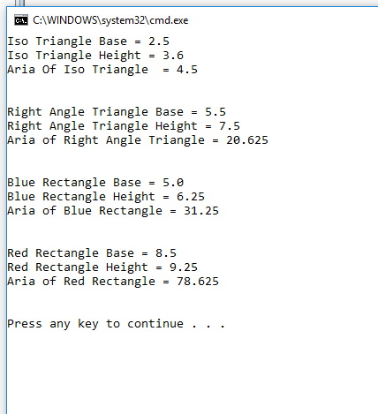

9) Algorithim
Write your equation to calculate area of the object
(BBB*CCC)+(DDD*FFF)
Which algorithm does this match?
Vertical Rectangle
Which of the algorithms is incorrect? why?
Three Times Square, because you cannot assume all 3 squares will be same size.
10) Lab1e: Algorithms
Why are variables d,e calculated?
Because we cannot assume this Size of square. So, to get correct value. We need to calculate the side D & E.
You should have an updated Template.java on your usb drive
Print your output code (with updated variable names)
use copy/paste to copy output below

Template file output -
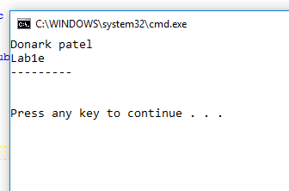

11) Lab1f - Errors
Print code
copy output below
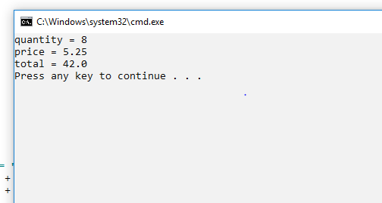
You may print out the lab to submit or you may submit electroically. See: SubmittingLabsElectronically in Reference Documents Module.
Submit:
This answer sheet
Source Code Lab 1d
Source Code Lab 1e

